Problem Two

Rules:

1. At the start point the robot should stand still. There should be a button to start the robot. The robot has to pick up given objects( cylindrical in shape)(pepsi bottle small 750 ml ) either manually or autonomously.
2. When the weight picked up is 500g, the robot should choose line 1 autonomously and go along the given path and unload the weight at given area at ground level.
3. After unloading the robot should return to the starting point without line following.
4. Then it has to pick up objects again. When the weight is 1kg, it has to autonomously choose line 2 and go along the path and unload the object or objects at a height of 500mm and return to start point.
5. Robot dimension: 500mmX500mmX1000mm
6. Total time for completion is 3 minutes.
7. NOTE: The unloading area 2 is at height 500mm.

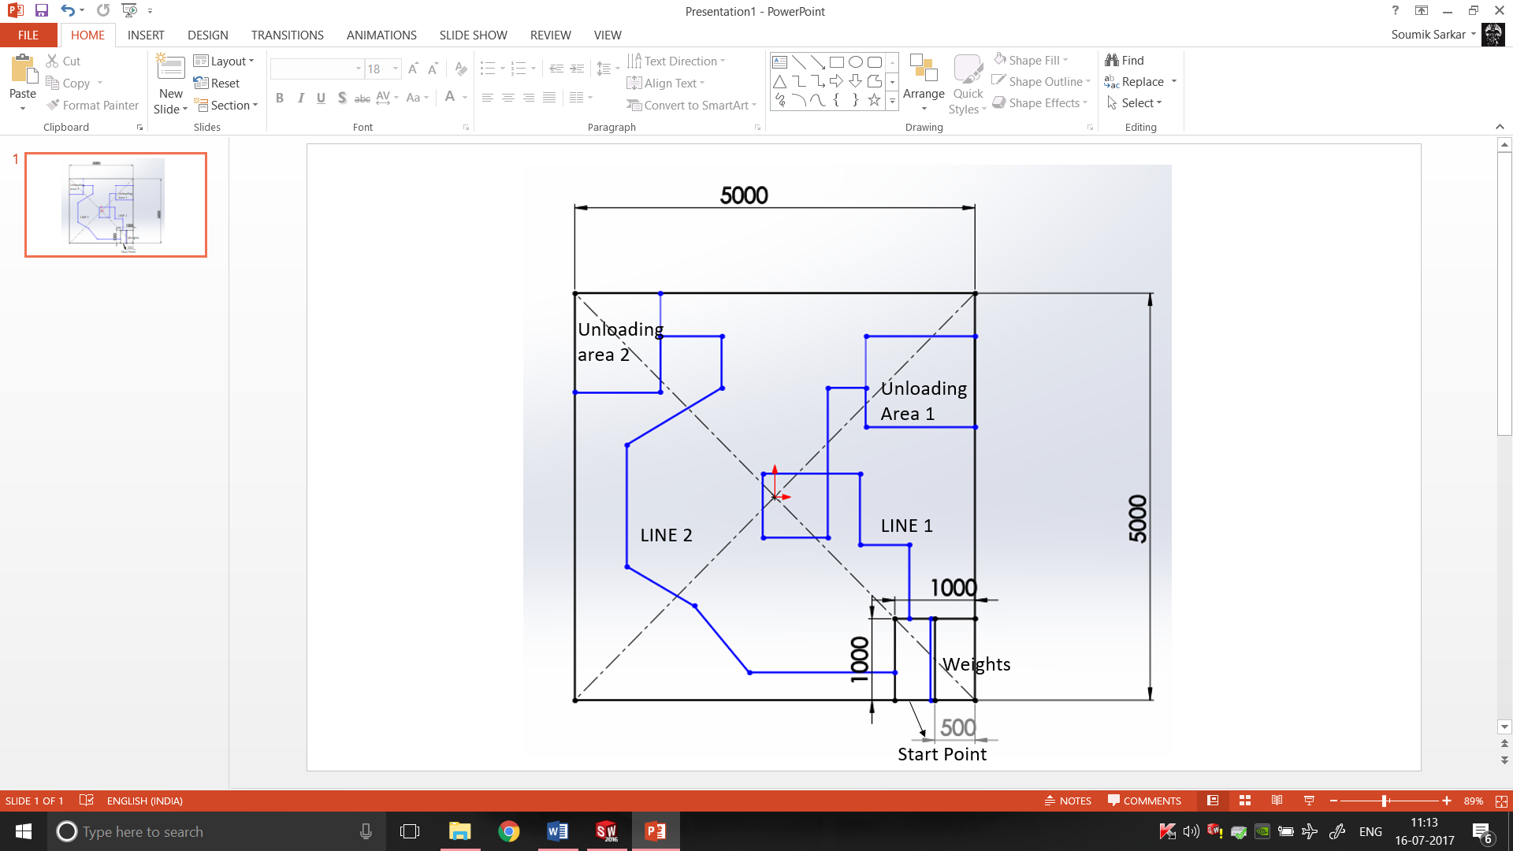

Documentations:-

Drive:-

We had decided to go for X wheel drive as we needed good mobility due to many turns of the tracks in the arena. For X wheel drive we needed omni- wheels. When the design was made we found out that we couldn’t go for omni-wheels as the mount for those wheels was not a suitable option for our design. So we decided to go for standard wheels with 7cm diameter and 4cm thickness with a hole in the shaft to put screws in.

Motor drivers:-

According to the weight of the bot(20kg) and the motor calculations, we had to go for 10kgcm and torque 300rpm motors, but in our inventory there weren’t 4 motors with the same specs(ie. Torque and rpm). So we decided to use the motors with the same torque and to control the rpm with pulse width modulation(PWM) of the motor drivers(MD10A).

10kgcm motors required a high current input and a 12V supply to work, so we couldn’t go for L298 or L293D as they wouldn’t be able to provide the required amount of current and also it had the risk of burning due to the high discharge current of LiPo battery .

Since the new recruits were divided into 2 teams, we had a shortage of one dual channel MD10A motor drivers, hence we had to use 1 dual channel and 2 single channel motor drivers for all the 4 motors.

On the day of finalizing the motor wirings, few events really delayed our work. Since the motor drivers were old, the bases of the screw connectors were rusted and hence they were breaking from the soldered part of the board. So we had to desolder the remaining part of the pins and then solder the screw connectors to the board. For this we had almost lost 4 hours it was really difficult to desolder the pins. At last we decided to directly solder the battery and motors wires to the back of the motor driver. Since there was no tether in the board, we had to put M-seal on the soldered wires and let it dry for 12 hours. So our work was delayed by a whole day.

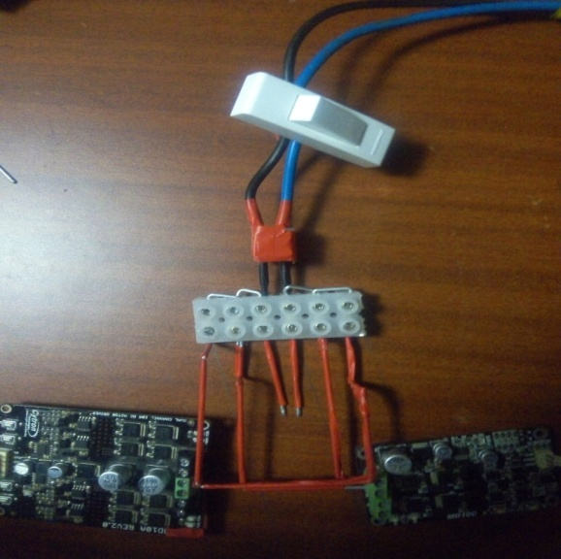We were using 3 motor drivers so we had to connect all of them in parallel so that each of them get the same power supply. We decided to use an array of 6 terminal blocks(bus bars) and connect the battery in parallel to the motor drivers. We had a shortage of thick wires , so we used thin filler rods to connect the supply and the motor drivers.